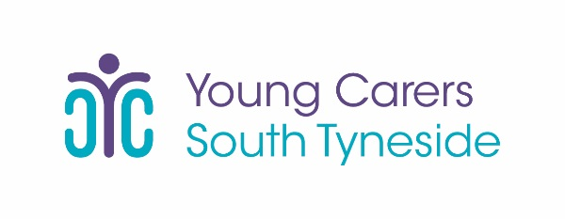

TEN South Tyneside Young Carer’s Project
Marsden Road Health and Wellbeing Centre
Marsden Road
South Shields
NE34 6RE

Year 6 Leavers Moving to New Schools for Year 7
Please fill in this form if your child is leaving to attend a new school in September:
Young Carers Name

New School

Signed (Parent/ Guardian)

These forms can be returned to a member of staff, emailed or posted to the addresses listed at the bottom of this page,
Thanks in advance,
South Tyneside Young Carers Team

